**Whistleblowing in Software Industry Communities on Reddit**

**Annotation guide**

This document will describe the annotation process related to the Master Thesis by Abimanyu Ravi and Magnus Larsen. It will be used as a guideline to ensure harmony between both annotators and allow for precise replicability in the event of related future work. This guide includes the different labels, their definitions, and text examples that could be labeled as such.

**List of whistleblowing labels derived from the taxonomy presented in Soliman 2023**

| **Label** | **Definition** | **Example** |
| --- | --- | --- |
| General comment surrounding a whistleblower case | The post or comment reflects the opinions, experiences and remarks shared by users in discussions spurred by whistleblower cases. Can be mentions of the specific case but also regarding key people within the case, such as relevant decision makers. | Following the Frances Haugen case I asked my children to show me some of the horrific and degrading content they are exposed to on Instagram, Zuckerberg and Meta should be held accountable! |
| Article about whistleblower | The post or comment shares a news article related to whistleblower cases or specific whistleblowers. | BBC: Facebook whistleblower, Frances Haugen, ready to testify for Congress |
| Unrelated to whistleblowing | The post or comment is not relevant to the issue of whistleblowing in the software industry, such as spam, bots, off-topic discussions, or deleted comments. Also non-English comments. | Whistleblower exposes government on Twitter: lobbying from fuel companies doubled since UN climate report. |

**List of ethical issues related to the issue of whistleblowing in the software industry derived from Wright 2011, Soliman 2023, and Tijkhoeri 2024**

| **Ethical issue** | **Definition** | **Example** |
| --- | --- | --- |
| Privacy | The users’ identity and data are not kept secure or used for purposes other than what the user gave consent to. | Instagram shares user information with undisclosed third parties, whistleblower claims. |
| Content moderation | When the content moderation decisions of a platform or software censors diverse viewpoints or silences specific opinions. | Twitter exposed! Whistleblower details information related to shadow banning political accounts. |
| Addiction | The software company has unresolved addiction issues with its products such as excessive use, or deliberately extends user sessions with addictive design. | Meta purposefully designed Instagram reels to prolong user engagement and encourage repeated sessions, whistleblower alleges. |
| Cyberbullying | The case revolves around issues related to cyberbullying that remain unsolved | Harassment and cyberbullying runs rampant and TikTok’s reporting system can not remedy it. |
| Discrimination | The software discriminates against certain user groups | Internal LinkedIn documents disclosed: people of color receive less profile recommendations on average. |
| Misinformation | The dissemination of false information to spread untrue narratives and opinions | Fake news detection can not keep up with the spread of misinformation on YouTube. |
| Manipulation | Influencing the opinions of users by exposing them to certain content and harboring them from differing opinions | Internal documents within Meta states that divisive political content is purposefully recommended to increase app engagement with Facebook users. |
| Security | The software product or company does not take necessary measures to protect its infrastructure or the data of its users. | Former head of security at Twitter discloses systemic faults within the company and underlines risks of data leaks. |
| Algorithmic bias | Human biases are implemented in the software and automated by algorithms or systems. | Whistleblower alleges Instagram is aware of the racial biases in the application’s recommendation system but struggles to rectify it. |
| Sustainability | The software or company poses a threat to global sustainability by for example using harmful supply chains or having excessive energy usages. | Energy consumption at Amazon server centers reportedly reach skyhigh levels, according to leaked internal documents. |
| Whistleblower retaliation | A whistleblower experiences severe repercussions following the disclosure of wrongdoings, for example being terminated, shunned, or prosecuted. | Edward Snowden tried for treason and spying. |
| Safety | The software poses a threat to public safety or the company fails to comply with safety standards. | Leaked reports from Tesla research show high accident probabilities with new autonomous Model 8. |

**Annotation process**

* Read all information of the current post or comment available in the dataset sheet.

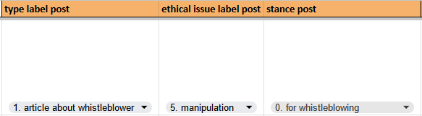

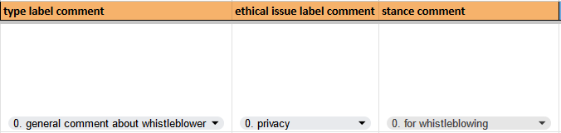

* Fill out the three drop down menu columns at the end of the row, these are pictured above and constitute the actual annotation.
* If you feel multiple labels fit the post in question, choose the one you feel fits the most and write a comment about the other related labels.
* If you feel there is no label that fits the post, fill in “unsure” or “unrelated” available in the ethical issue and stance columns.
  + If you are able to identify an ethical issue within a post that is not available to you in the dropdown menu, fill in “unsure” and write the ethical issue in a comment on the given cell.
* Stance is labeled as “For Whistleblowing” on an article if the publication effectively supports the whistleblower by giving them a platform, for example, by focusing on the wrongdoings they disclosed or focusing on possible retaliation they are experiencing as a result.

**Annotating selected posts based on relevance to whistleblowing**

A post should be marked as relevant to **whistleblowing** if it meets one of these criteria:

* Mentions whistleblowing in the software industry i.e., a whistleblowing incident at a software company or related to a software product.
* Mentions a known whistleblower or whistleblowing case i.e., Edward Snowden or Cambridge Analytica.
* If the post mentions anything that MIGHT be related to whistleblowing, for example mentioning leaked documents or mentions a report, go to the post using the post ID (reddit.com/r/technology/comments/{POST_ID}, and investigate whether it is in relation to whistleblowing or not.
  + If the post leads to an article click the link and skim the article.
  + If the article is hidden behind a paywall you can try to remove it by inspecting the element and deleting the html code tied to the paywall (Works on NYT).
  + You can also try to press CTRL+P or CMD+P quickly as the website is loading in to try and generate a PDF of the page before the paywall appears.